# Table of Contents:

**Table of Contents: 1**

**Scoreboard Web Application - Mr Thomas 1**

**Development Team 1**

**Software Architecture 2**

**Wireframe and UI Design 2**

**Completed Tasks 2**

**Future Goals 3**

**Development Notes 3**

**Remarks 3**

Known issues 3

**Facebook Video Call Effects - Mr Tran 3**

Apple frenzy 4

Beach Bomb 4

Singaball 4

StepUpRight 4

**Frailty Survey App via Flutter - Mr Tran 4**

**I-Sing Game Research - Mr Chris 5**

**Sources & Links 5**

# Scoreboard Web Application - Mr Thomas

To make a scoreboard application for I-SING via NodeJs’ framework, NextJS and ExpressJS.

**NextJS** is a full stack development framework, but we will be using it for the frontend for the design elements of the application. **ExpressJS** is a backend development framework and we will be using it for the middleware and backend API.

Instead of Javascript, we will be using **Typescript** for its data types and easy to document nature. It also has many built in functions that improves development speed. Via NodeJS, it will be converted to Javascript on its own before being sent to the website.

The expected product has 2 user profiles, **Admin** and **User**. Both of each have differing tasks, **creation and moderation** as well as **data collection**, respectively.

## Development Team

Supervisor: Mr Thomas Koh

Team Lead: Winston

FrontEnd Developers: Jiajun and Jiaxu

Designer & Artist: Clevon

## Software Architecture

The following diagrams will aid in the understanding and describe the functions used in this project.

ERD

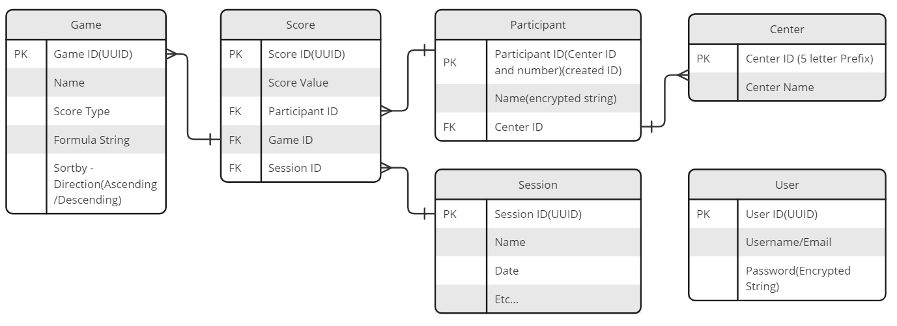

Done by: Winston

UML

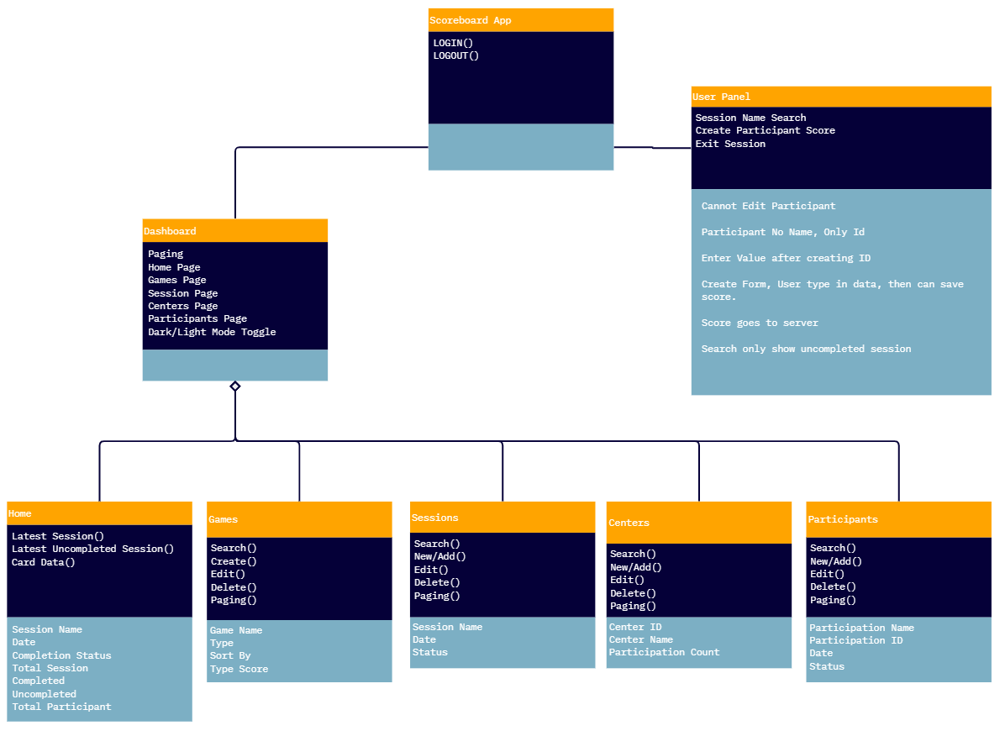

Done by: Jiaxu

## Wireframe and UI Design

Refer to following link:

Done by: Clevon

## Completed Tasks

Current Focus is on the front end, as it is easier to scope the use cases of the application before creating the backend. However, due to inexperience, progress has been slow and reduced focus has been given to the user panel. Fortunately, there is ample documentation on the admin dashboard, having the function to **generate user forms to be stored in a database** for the following tables: **Users, Games, Sessions, Centers, Participants, Scores**. More tables may be added if needed, but currently these are sufficient for our plans.

We have not decided where to host the website or database yet but we will continue work on the local host with a temporary seeded database on postgres. “.env” file to store data on **Vercel PostGres** for its hosted database and web deployment service. It stores secrets and database routers as well as encryption data, which is important for security

NOTE: Do not send this file to others and ensure that it is not posted into github.

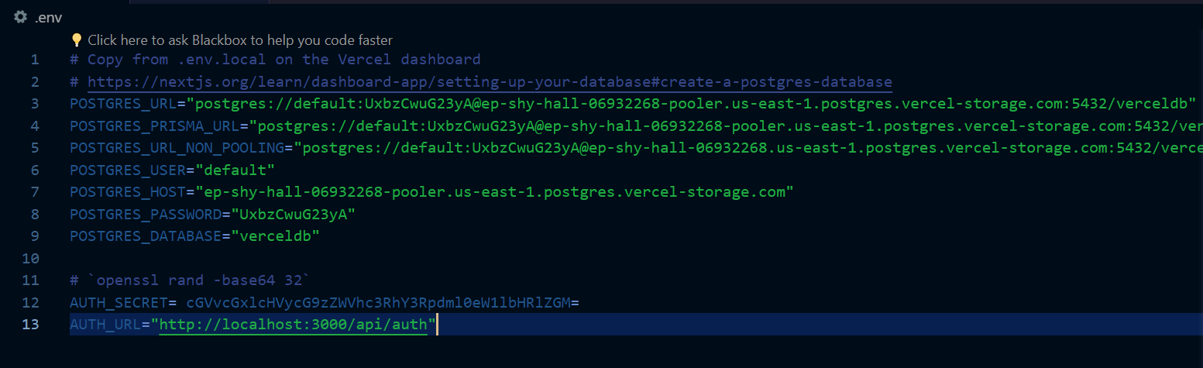

Links for vercel/postgres used for the database hosting

Notes here:

Winston: Tasked done and documentation, files involved and how to use them.

## Development Notes

We will be using Visual Studio Code and Typescript extension as the environment.

We will be using the NodeJS package with NPM for downloading and managing packages, allowing for ease of installing and updating plugins.

We will be using “heroicons” for iconography and TailwindCSS for designing the web page.

## Remarks

### Known issues

Session-Create Session Input for No.Participants allows the input of letter e/E and some other non number inputs, it is a built-in functionality of the number input type and cannot be changed.

<https://stackoverflow.com/questions/31706611/why-does-the-html-input-with-type-number-allow-the-letter-e-to-be-entered-in>

# Facebook Video Call Effects - Mr Tran

Enter the project via meta sparks studio, accompanying apps include facebook messenger(video calls) and mobile meta sparks player(phone based testing, both ios and android compatible)

Enable USB debugging and connect project to device(else use software provided emulator), send to device via the accompanying app to view effect. Note: enable the app first and ensure that the software recognizes the app and video call session respectively.

## Apple frenzy

* Gravity with good and bad apples
* Has an error called sharpwrap that is not supported on most social media platforms, a property in the scene hierarchy’s ECS
* Effect works on emulator and meta spark player but does not export on messenger and instagram
* Project does not have sharpwrap imported or entities using sharpwrap component
* Project settings are the same as the following games in series

## Beach Bomb

* Balancing on a tightrope

## Singaball

* Table Tennis

## StepUpRight

* Whack-A-Mole

# Frailty Survey App via Flutter - Mr Tran

App runs on VS code with flutter and firebase

Uses Xcode for ios

Uses android studio + android SDK/Java Runtime

Uses iphone emulator on macbook

Has error when building for android sdk

* Inaccurate java version detection
  + Android studio - hedgehog(1.8, api 24) is not sufficient
  + Version 11 java runtime required
* Android studio is not detected^, is already downloaded
* Requires development team

Has error when building for IOS

* Requires development team
* No publishing license

# I-Sing Game Research - Mr Chris

Played switch games and exergames to record following details

1. Muscle group and intensity of the activity
2. Domain of fitness
3. Social impact and gameplay behavior of social games
4. Brain game and mental impact as well as cognitive improvement

Research papers with following focus

1. Fall prevention/better balance
2. Habitual exercise sessions
3. Improve mental faculty
4. Acceptance to future events/higher participation rate

# Sources & Links

<https://miro.com/app/board/uXjVMkl_o2A=/?share_link_id=548989296126>